**Twitter API**

**1. Set Up a Twitter Developer Account:**

Go to the Twitter Developer website.

Log in with your Twitter account.

Create a new Twitter Developer Account if you haven't already.

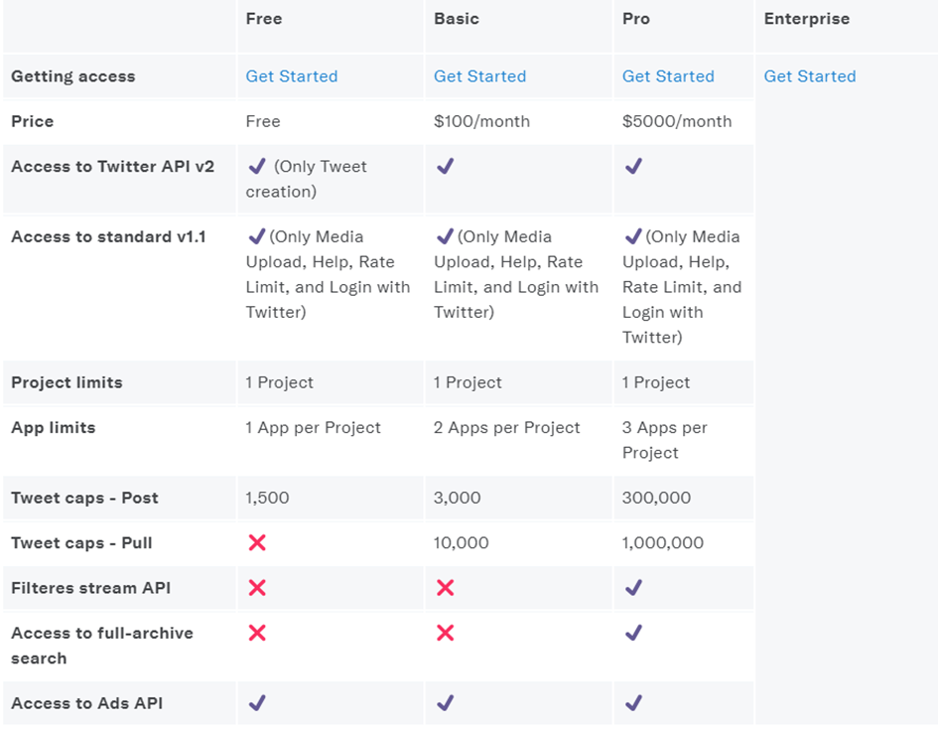

**2. Create a Twitter Application:**

Once logged in, click on "Projects & Apps" from the menu.

Create a new Project and then add an App to that project.

Fill out the required details for your app (name, description, website). You can put any relevant information for your project.

Once your application is created, go to the "Keys and Tokens" tab.

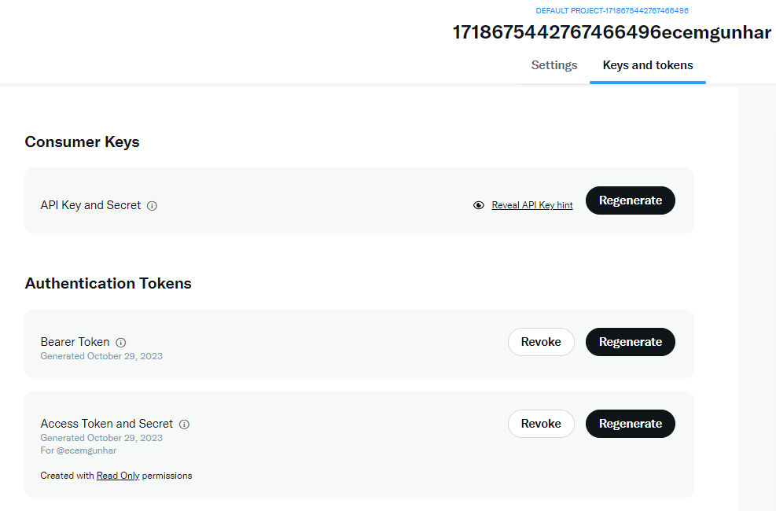

**3. Generate API Keys:**

In the "Keys and Tokens" tab, you'll find your API Key, API Secret Key, Access Token, and Access Token Secret. These credentials are required to access Twitter's API.

**4. Connect to Twitter API using Python:**

You can use the Tweepy library in Python to interact with the Twitter API. If you haven't installed it, you can do so using pip:

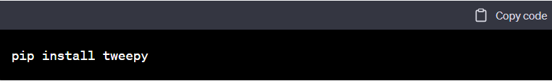

Here is an example code snippet to connect to Twitter API using Tweepy:

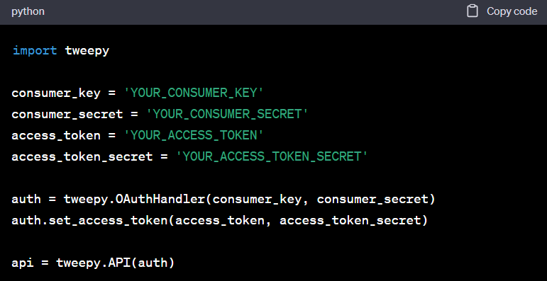

**Twitter API v2 - Python**

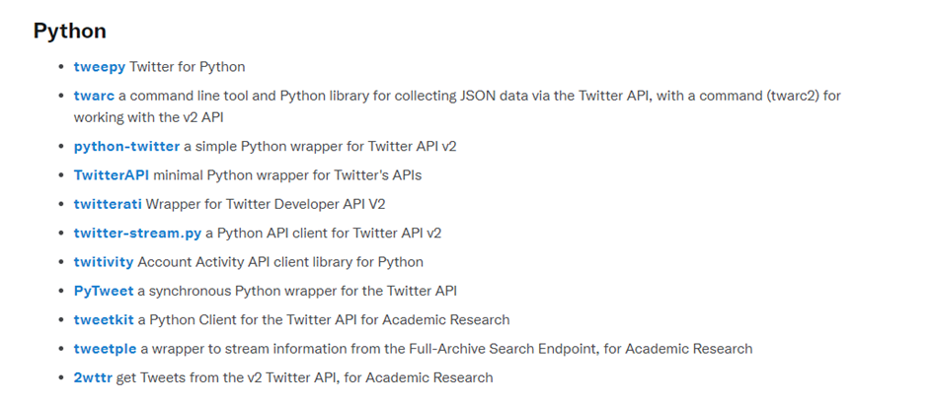

**5. Fetching Tweets:**

You can use Tweepy to fetch tweets based on specific queries, hashtags, or user accounts. For example, to get tweets containing a specific keyword:

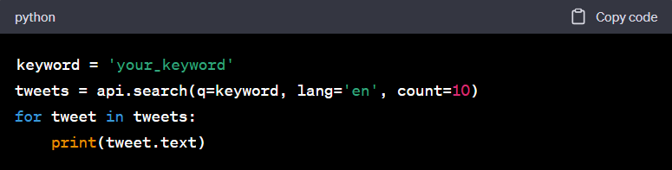

**6. Connecting to ChatGPT API:**

Our e-mail account: [**thefinetuners5@gmail.com**](mailto:thefinetuners5@gmail.com)

To connect to the ChatGPT API, you'll need to have an API key from OpenAI. This API key will be used to authenticate your requests.

You can use the OpenAI Python library for this purpose. If you haven't installed it, you can do so using pip:

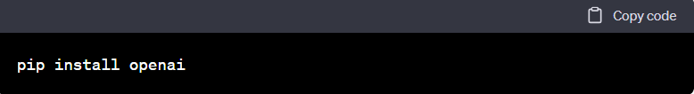

You'll also need to import the library:

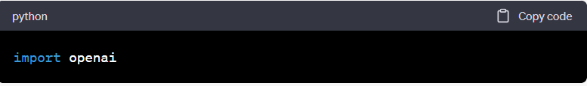

Initialize the OpenAI API with your key:

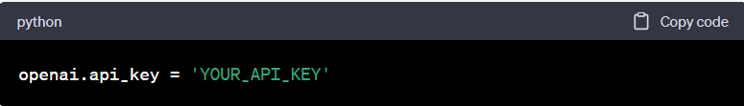

**7.Interacting with ChatGPT:**

You can use the openai.ChatCompletion.create() method to interact with ChatGPT. For example:

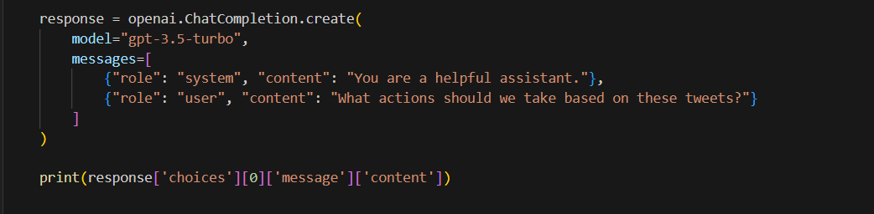

**ChatGPT API**

**1. Sign Up and Log In:**

If you haven't already, sign up for an OpenAI account or log in to your existing account.

**2. Navigate to the OpenAI Dashboard:**

Once you're logged in, access the OpenAI Developer Dashboard. You can typically find this in your account settings or a developer section on the OpenAI website.

**3. Create an Organization:**

If you're working on a group project, it's a good idea to create an organization within the OpenAI Dashboard. This will allow you to manage and share API keys with multiple team members. Look for an option to create an organization.

**4. Create an API Key:**

Within your organization, you can create an API key. This key will represent your group project. Follow the instructions provided in the dashboard to create a new API key.

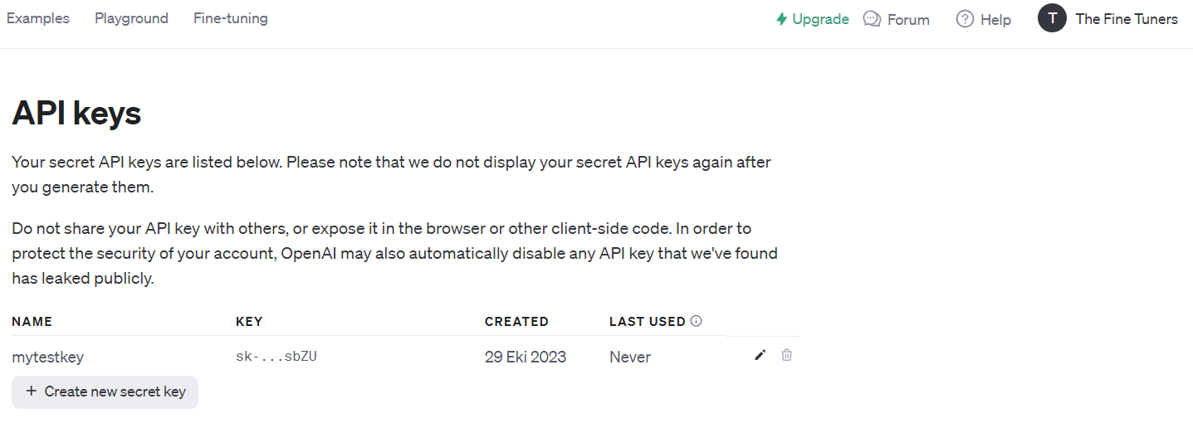

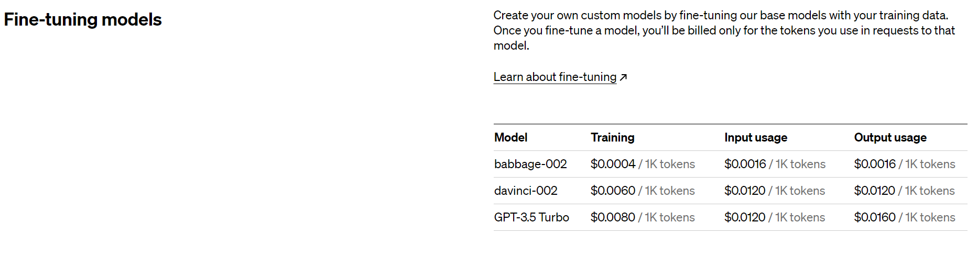

<https://openai.com/pricing>